GroupBuild Competitor Analysis & Strategic Opportunity Report
Version 2 – Developer-Oriented Brief

1. Introduction
This version of the report is tailored for the GroupBuild developer community, focusing on highly actionable tasks and examples. It identifies key strategic gaps in the civic tech ecosystem, explores specific design and functionality patterns from competitors, and proposes feature enhancements that align with GroupBuild’s values of transparency, decentralization, and digital trust.

2. Updated Visual Aids
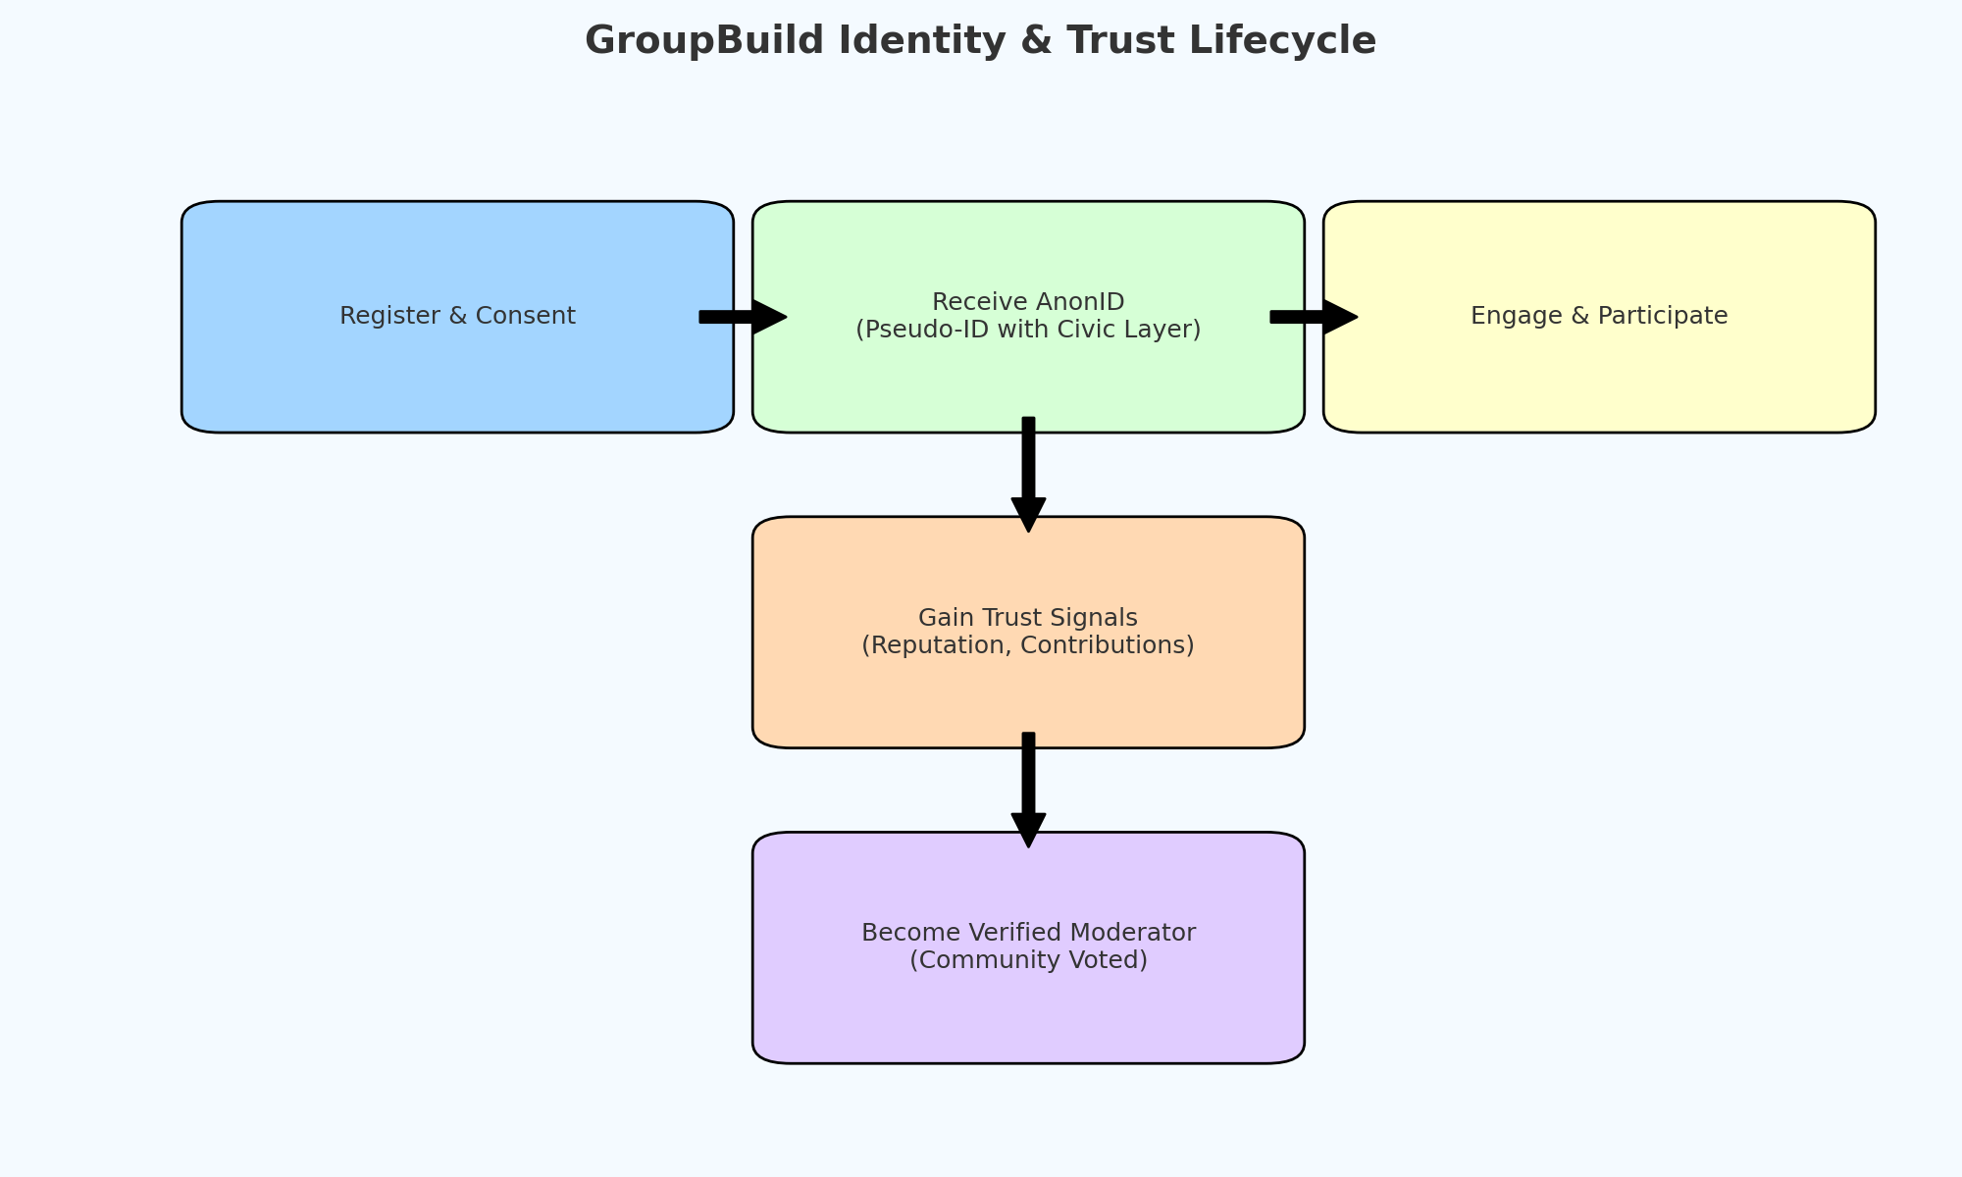
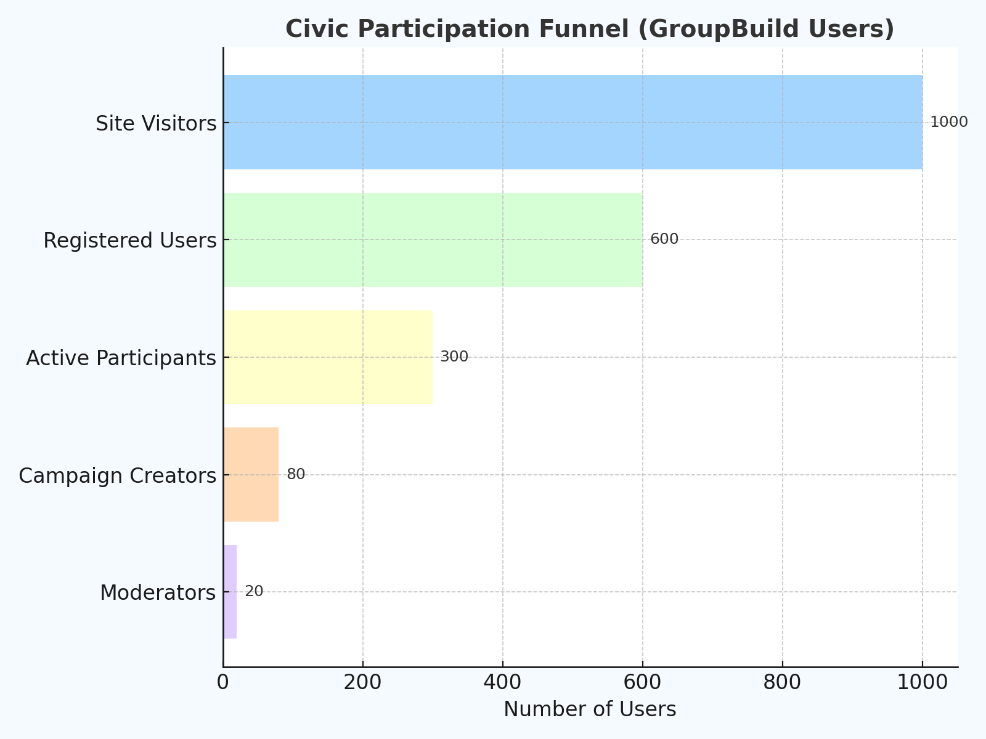

3. Feature Opportunities & Developer Tasks Outstanding
Secure Pseudonymous Identity
Study Keybase and NymTech (https://nymtech.net/) for modular identity layers. Create AnonID schema with civic attribute fields and progressive trust layering.
Moderation and Trust Metrics
Use Discourse.org’s mod dashboards (https://meta.discourse.org/t/moderator-guide-documentation/134123) as reference. Implement logs of community actions and transparency metrics on moderation outcomes.
Community Maps & Event Layers
Model after Decidim's participatory mapping (https://docs.decidim.org/). Add editable polygon layers, icon tagging, and auto-generated ‘Action Zones’ that fade over time if inactive.
Guided Campaign Builders
Adapt NationBuilder's 'Actions' UX (https://nationbuilder.com/features). Develop drag-and-drop campaign tool with milestones and community impact tracking.
Onboarding Flows for New Users
Review Loomio’s helpbot approach. Design step-by-step onboarding with animated explainers and localized starter templates.
Open Plugin Architecture
Use WordPress-style plugin loading structure. Reference Decidim's modular API. Allow opt-in activation for features like debates, heatmaps, AnonID badges, etc.

4. Research Assignments
- Compare Decidim’s open APIs and participatory budgeting tools.
- Analyze Loomio’s structure for decision tracking and asynchronous voting.
- Reverse-engineer Polis’s clustering and visual opinion mapping.
- Create a public doc comparing Eventbrite’s UX vs GB’s proposed event module.
- Review Discourse’s trust level algorithm and user trust level API.
- Study Keybase’s public/private messaging system and identity proofs.

5. Suggested Strategic Priorities Q3 Development
1. Finalize AnonID schema with public-private layers.
2. Prototype moderation tools with transparency logs.
3. Build demo version of interactive map with ‘Zones of Interest’.
4. Create tutorial-driven first-time-user experience.
5. Launch plugin system with at least 3 active module types.

